 Translated from Chinese (Simplified) to English - www.onlinedoctranslator.com

BL200-R

Brushless DC Drives

Manual V1.0

BL200-R 1
Brushless DC Drives 1
manualV1.0 1
1. Introduction 1
2 Electrical performance and environmental indicators 1
3. Mechanical dimension drawing unit(mm) 2
4 Driver interface and wiring diagram 2
5 Function selection, setting and operation 3
6 Motor speed regulation and settings 4
7 Motor status-abnormal handling 4
8 Modbus communication 5
Write a program to send a single byte with 1 start bit and 2 stop bits according to the baud rate 6
Write a CRC check program 7
Determine the structure of ADU according to the function and sendADU 7

1. Introduction
BLD300 brushless DC motor driver is a high-performance, low-cost brushless DC motor driver for 20W~300W brushless DC motors. This brushless DC driver can also be expanded to support Modbus communication protocol, providing users with more flexible choices in practical applications.

1.1 Product Advantages
● It also has built-in potentiometer RV speed control and external analog speed control
● Supports working in the voltage range of 24V~60V
● Supports -20℃~+55℃ ambient operating temperature range
● Speed ​​open-loop or closed-loop is optional. When closed-loop control is performed, the speed does not drop under load at rated power.
● Supports brushless motor drive with rated power ranging from 20W to 300W
● 5Seconds of stall waiting time
● BRKExternal input signal power-off reset alarm
● Support Modbus communication protocol, suitable for users to use touch screen or PC control

2 Electrical performance and environmental indicators

2.1 Electrical specifications
Driver parameters | Minimum | Rating | Maximum
Input voltage DC(V) | 18 | twenty four | 60
Bus current (A) | ----- | 4 | 15
Applicable motor speed (rpm) | 100 | 3000 | 3500
illustrate:
The minimum motor speed in closed-loop control requires that the pole pairs set by the driver be consistent with the pole pairs of the motor; in open-loop control, this value is related to the design of the motor itself and may not be the value in the table; due to the wide variety of usage scenarios and the differences in the workmanship of brushless motors, the recommended minimum operating speed of the motor is not less than 200 rpm

2.2 Environmental indicators.
Environmental factors | Environmental indicators
Cooling method | Natural cooling or forced cooling
Use occasions | Avoid dust, oil and corrosive gas
Operating temperature | -20℃~+55℃
Storage temperature | -30℃~+70℃

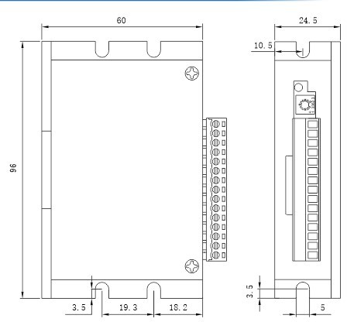
3. Mechanical dimensions (mm)

4 Driver interface and wiring diagram

4.1 Driver Interface
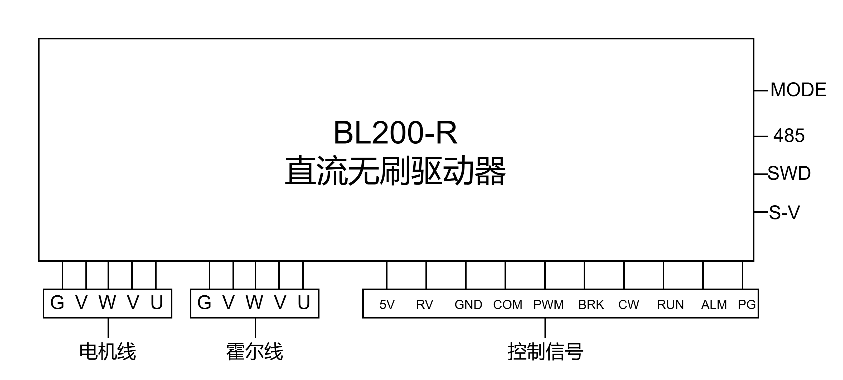

● Supports extended output power adjustment (please contact the business for related information, standard products do not have this function) P-SV

4.2 Port Signal Description
Signal | Terminals | content
Power Input | GND | DC power input negative pole
Power Input | 24V | DC power input 18V~60V
Motor connection | W | Brushless DC Motor W Phase
Motor connection | V | Brushless DC Motor V Phase
Motor connection | U | Brushless DC motor U phase
Hall signal | +5V | Brushless DC motor Hall signal 5V
Hall signal | GND | Brushless DC motor Hall signal ground wire
Hall signal | HW | Brushless DC motor Hall signal HW
Hall signal | HV | Brushless DC motor Hall signal HV
Hall signal | HU | Brushless DC motor Hall signal HU
Motor  control  Signal | +5V | Brushless DC motor power cord
Motor  control  Signal | RV | (1) Connect to speed potentiometer (2) External analog signal input (built-in speed regulator adjusted to minimum)
Motor  control  Signal | GND | Motor power ground
Motor  control  Signal | COM | Motor reference 0V
Motor  control  Signal | PWM | (1) Connect to PWM speed regulation
Motor  control  Signal | BRK | BRK terminal and When the GND terminal is disconnected, the motor runs; when it is short-circuited, the motor brakes and stops.
Motor  control  Signal | F/R | F/R terminal and When COM is shorted, the motor reverses
Motor  control  Signal | RUN | The motor needs to be connected to RUN ---COM
Motor  control  Signal | ALM | Motor alarm prompt
Motor  control  Signal | PG | Motor speed signal output

5 Function selection, setting and operation

5.1 Start and stop
When the 485 communication is not connected, direct speed adjustment (RV knob or SV port) can make the motor run. When connected to 485, the upper computer controls

5.2 Braking
Disconnecting or connecting the connection line between BRK and GND can control the natural operation and quick stop of the motor. When BRK and GND are short-circuited, the motor stops quickly; otherwise, the motor runs normally. By connecting a switch between GND and BRK or using PLC to control its on and off, the switching between motor operation and quick stop can be achieved. This function works regardless of whether 485 communication is connected or not.
When the driver has a red light alarm, you can also connect BRK and GND, and then release them to restore the alarm without powering off.

5.3 Open-loop/closed-loop operation
(1) When 485 communication is enabled, only BRK is valid at the driver control port.
(2) Driver default configuration parameters: 4-pair level, open loop operation
(3) When 485 communication is disabled, the drive port can be controlled by PLC
Note: In closed loop, the maximum speed of standard products is set to 3000rpm by factory, and the maximum speed can be modified through 485 communication. In open loop, the maximum speed is related to the factory setting of the motor and has nothing to do with the driver.

5.4 Stall torque and function retention
When the load suddenly increases or hits an obstacle, the motor's output current is limited to the driver's default maximum current limit to protect the motor and driver. Due to the effective holding force, force drops and unreasonable collisions are prevented. If the cause of the rotor constraint is resolved within 5 seconds, the motor can rotate again.
If the cause of the rotor constraint is not resolved within 5 seconds, the motor will stop and alarm. A reset command is required to restart the motor. Removing the obstacle alone will not restart the motor.

6 Motor speed regulation and settings
(1) Built-in potentiometer speed control: When the built-in potentiometer is not connected to an external potentiometer, the motor starts to run by rotating the built-in speed control potentiometer Sv clockwise. If the built-in potentiometer Sv is rotated clockwise, the motor speed increases. If the built-in potentiometer Sv is rotated counterclockwise, the motor speed decreases.
(2) External potentiometer speed control: When the built-in potentiometer Sv is adjusted counterclockwise to the lowest position, the external potentiometer RV can be used for speed control. External analog signal: supports DC 0~5V input, and the adjustable speed range is the same as that of the built-in potentiometer.
(3).PWM speed regulation: It is necessary to switch to the external analog speed control mode, and the built-in potentiometer Sv must be in the lowest or closed state. The recommended frequency range is 3KHz~15KHz, high level 5V, low level 0V.
Note: When closed-loop control is in progress, the motor parameters must be accurately set.

7 Motor status-abnormal handling
When the motor has overvoltage, Hall signal error, stall, overcurrent, etc., the driver will send out an alarm signal and stop working. Note that when the motor is working normally, the red light may be on all the time. This is because the driver is limiting the phase line current, which is not considered abnormal.
Alarm indication | meaning | Cause
Green light is always on | Motor normal operation | -
Red light is on | Motor not enabled | -
1 green 1 red | Motor overspeed | The motor pole pair number does not match or stalls
1 Green 2 Red | Motor stall | External torque is too large
1 green 3 red | Driver voltage is too high | The supply voltage is too high
1 Green 4 Red | Driver overcurrent | Motor wiring error or MOS short circuit
1 green 5 red | Driver voltage is too low | Supply voltage is lower than 18VDC
1 Green 6 Red | Communication Error | The communication line is not connected properly
Red light flashes continuously | Unknown fault | Factory repair

8 Modbus communication

8.1 All server holding register addresses
RS-485 communication slave address selection (1-F) (SW1 (high) ------> SW4 (low))
SW1 | OFF | ON | OFF | ON | OFF | ON | OFF | ON | OFF | ON | OFF | ON | OFF | ON | OFF | ON
SW2 | OFF | OFF | ON | ON | OFF | OFF | ON | ON | OFF | OFF | ON | ON | OFF | OFF | ON | ON
SW3 | OFF | OFF | OFF | OFF | ON | ON | ON | ON | OFF | OFF | OFF | OFF | ON | ON | ON | ON
SW4 | OFF | OFF | OFF | OFF | OFF | OFF | OFF | OFF | ON | ON | ON | ON | ON | ON | ON | ON
Slave Address | broadcast | 0x01 | 0x02 | 0x03 | 0x04 | 0x05 | 0x06 | 0x07 | 0x08 | 0x09 | 0x0a | 0x0b | 0x0c | 0x0d | 0x0e | 0x0f
All the server holding register addresses that the client can read: (can be increased according to customer definition)
Server address (1 byte) | Function code  (1 byte) | Holding Registers  Access start address (2 bytes) | Access data size (2 bytes) | CRC Check  (2 bytes) | Functional Description
0xnn | 0x03 | 0x0056 | --- | CRC Check | Read the drive setting speed (unit: rpm)
0xnn | 0x03 | 0x005F | --- | CRC Check | Read the motor feedback speed (unit: rpm)
0xnn | 0x03 | 0x006A | --- | CRC Check | Read the drive brake signal (0 or 1)
0xnn | 0x03 | 0x006D | --- | CRC Check | Read the drive direction signal (0 or 1)
0xnn | 0x03 | 0x0076 | --- | CRC Check | Read the drive operation signal (0 or 1)
0xnn | 0x03 | 0x0086 | --- | CRC Check | Read RS-485 connection status (0 or 1)
0xnn | 0x03 | 0x008A | --- | CRC Check | Read drive operating mode
0xnn | 0x03 | 0x0092 | --- | CRC Check | Read the maximum speed setting (unit: rpm)
0xnn | 0x03 | 0x00B6 | --- | CRC Check | Read the Hall truth table (Ha Hb Hc high bit first)
0xnn | 0x03 | 0x00BB | --- | CRC Check | Read the limiting current (unit: mA)
0xnn | 0x03 | 0x00CC | --- | CRC Check | Read alarm code
0xnn | 0x03 | 0x00DD | --- | CRC Check | Read the set number of pole pairs
All server holding register addresses that can be written by the client: (can be increased according to customer definition)
Server address (1 byte) | Function code  (1 byte) | Holding Registers  Access start address (2 bytes) | Access data size (2 bytes) | CRC Check  (2 bytes) | Functional Description
0xnn | 0x06 | 0x0056 | --- | CRC Check | Write drive set speed (unit: rpm)
0xnn | 0x06 | 0x005F | --- | CRC Check | Write speed loop parameters
0xnn | 0x06 | 0x006A | --- | CRC Check | Write drive brake signal (0 or 1)
0xnn | 0x06 | 0x006D | --- | CRC Check | Write drive direction signal (0 or 1)
0xnn | 0x06 | 0x0076 | --- | CRC Check | Write drive operation signal (0 or 1)
0xnn | 0x06 | 0x0086 | --- | CRC Check | Write drive operating mode
0xnn | 0x06 | 0x008A | --- | CRC Check | Write the maximum speed setting (unit: rpm)
0xnn | 0x06 | 0x0092 | --- | CRC Check | Write limit current (unit: mA)
0xnn | 0x06 | 0x00B6 | --- | CRC Check | Write the set number of pole pairs
0xnn | 0x06 | 0x00BB | --- | CRC Check | Write drive operating mode


8.2 Client PC and other equipment communication steps

This section applies to clients thatPCIf the user uses a touch screen to communicate with this driver, you can skip reading this part.
Before communicating, users need to have a certain understanding of the following two standards:
①GB/T 19582.1-2008: "Industrial Automation Network Specification Based on Modbus Protocol Part 1: Modbus Application Protocol"
②GB/T 19582.2-2008: "Industrial Automation Network Specification Based on Modbus Protocol Part 2: Implementation Guide for Modbus Protocol on Serial Links"
PC example:
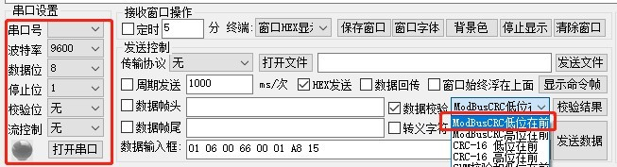
The client PC serial port debugging assistant can be set according to the following conditions
Baud rate 9600 Data bit 8 Stop bit 1 ModbusCRC low bit first No check bit
When communicating, users need to write programs according to the following steps
① Determine the address of the drive
② Write a program to send a single byte with 1 start bit and 2 stop bits according to the baud rate
③ Write a CRC check program
④ Determine the structure of ADU according to the function and send ADU
⑤ Analyze the data according to the ADU returned by the driver
- Write the send band according to the baud rate1The starting position,2A single-byte program with 1 stop bit
For details about this part, users can refer to the national standard GB/T 19582.2-2008. Note that the order of sending each character or byte is from left to right: least significant bit (LSB)...most significant bit (MSB)

1

In the figure above, the start signal of a single data packet of serial communication is represented by a data bit of logic 0, and the two stop signals of the data packet are represented by data bits of logic 1.
- Write a CRC check program
This driver uses the CRC-16/Modbus algorithm model. If users need to know more about the details of this verification method, they can refer to Appendix B.2 in the national standard GB/T 19582.2-2008. The C source program for generating the verification code is given below for user reference.
typedef unsigned char u8;
typedef unsigned int u16;
/*
* @brief Generate verification code
*@param *ptr The array for storing information codes, with the first address of the array being the first byte of ADU
* @param lengthADU Excluding the number of bytes of the checksum
* @retval u16 Check code
*/
u16 getCRC16(u8*ptr,u8 length)
{
u8 i; u16 crc = 0xFFFF;
if(length == 0)
length = 1; while(length--) {
crc ^= *ptr;
for(i = 0; i < 8; i++){ if(crc & 1){
crc >>= 1;
crc ^= 0xA001;}
else
crc >>= 1;
}
ptr++;
}
return(crc);
}

- Determine the structure of ADU according to the function and send ADU

8.3 Communication code sending routine
Since this driver only uses two function codes: 03 and 06, you only need to be familiar with the formats of two ADUs. For the request ADU and response ADU of the 03 function code, refer to Section 7.3 of GB/T 19582.1-2008. For the request ADU and response ADU of the 06 function code, refer to GB/T 19582.1-2008. The following table lists the commonly used ADUs for user reference. The following example sets the communication when the address dial is set to 1.
Read Register
Read motor feedback speed | send:01 03 00 5F 0001 B4 18  take over:01 03 02 02 48B9 12  For example:(The motor speed is 500rpm)
Read alarm code | send:01 03 0076 0001 65 D0  take over:01 03 02 00 00 B8 44  For example:(Alarm code is 0)
Read the number of pole pairs | send:01 03 0086 0001 65 E3  take over:01 03 02 00 04 B9 87  For example: (the number of pole pairs is4)
Read the maximum speed of analog speed regulation | send:01 03 0092 0001 27 E7  take over:01 03 020B B8 BF 06  For example: (The maximum speed of analog speed regulation is3000rpm)
Unicast mode write register
Write 485 control enable | send:01 0600B6 0001 A9 EC  take over:01 06 00 B6 00 01 A9 EC
Write pole pairs 2 | send:01 060056 01 F4 69 CD  (When 485 control is enabled) Receive:01 06 00 56 01 F4 69 CD  (485 Control Disabled) Receive:0186 FF 02 20
Write setting speed 500rpm | send:01 060092 01 F4 28 30  (When 485 control is enabled) Receive:01 06 00 92 01 F4 28 30  (485 Control Disabled) Receive:0186 FF 02 20
Write Inversion | send:01 06006D 00 01 D9 D7  (When 485 control is enabled) Receive:01 06 00 6D 00 01 D9 D7  (485 Control Disabled) Receive:0186 FF 02 20
Broadcast mode write register
Write 485 control enable | send:00 06 00 86 00 02 E8 33  Receive: No response
Write setting speed 1100rpm | send:00 06 00 56 04 4C 6B 3E  Receive: No response

